**The Quick View of Price Surge in Nigeria Economy Using Data Science Challenge**

**EDA Report for 2000_onwards Dataset**

**Sahar Nikoo**

1. **Dataset Description**

The Dataset (**Dataset: 2000_onwards**) contains economic and financial data for Nigeria spanning 25 years, with 15 columns representing various indicators. The data includes:

1. **Year** (int64): No missing values
2. **Consumer Price for all items** (float64): No missing values
3. **Nigerian Government Expenditure** (float64): No missing values
4. Various changes in **All Items and Food prices (Year on Change and 12 Months Avg. Change)**, with 12% missing values each
5. Changes in **All Items Less Farm Produce and All Items Less Farm Produce and Energy** **(Year on Change and 12 Months Avg. Change),** with 12% missing values each
6. **Overall Fiscal Balance, Including Grants (% of GDP)** (object): 16% missing values
7. **Government Debt (% of GDP)** (float64): 16% missing values
8. **Foreign Reserves Gross and Foreign Reserves Liquid** (float64): 24% missing values each

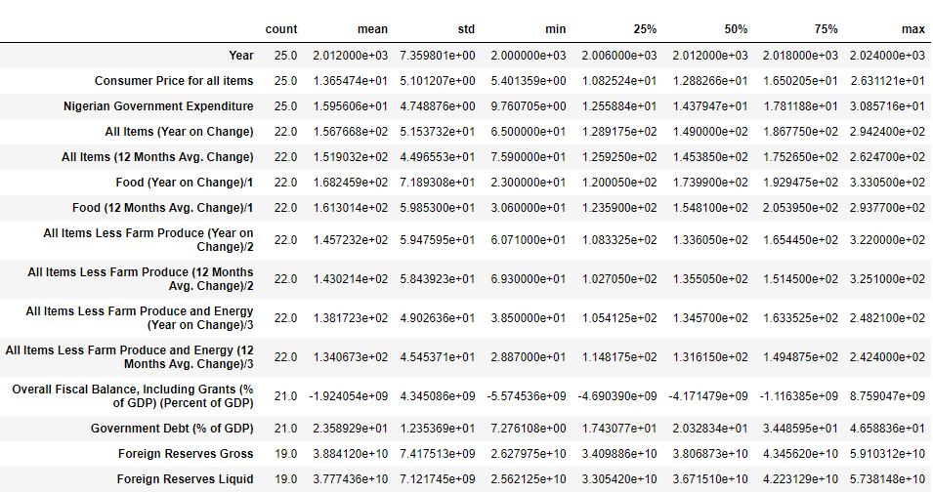**2- Dataset Statistics:**

**3-1- Univariate Analysis: Histogram Plots**

As histogram plots represent:

1. **Year**: The distribution of data points across the years appears uniform, indicating that the data spans evenly from 2000 to 2024.
2. **Consumer Price for all items**: This histogram shows a somewhat normal distribution with a peak around the middle range of values and a few lower counts at the higher end.
3. 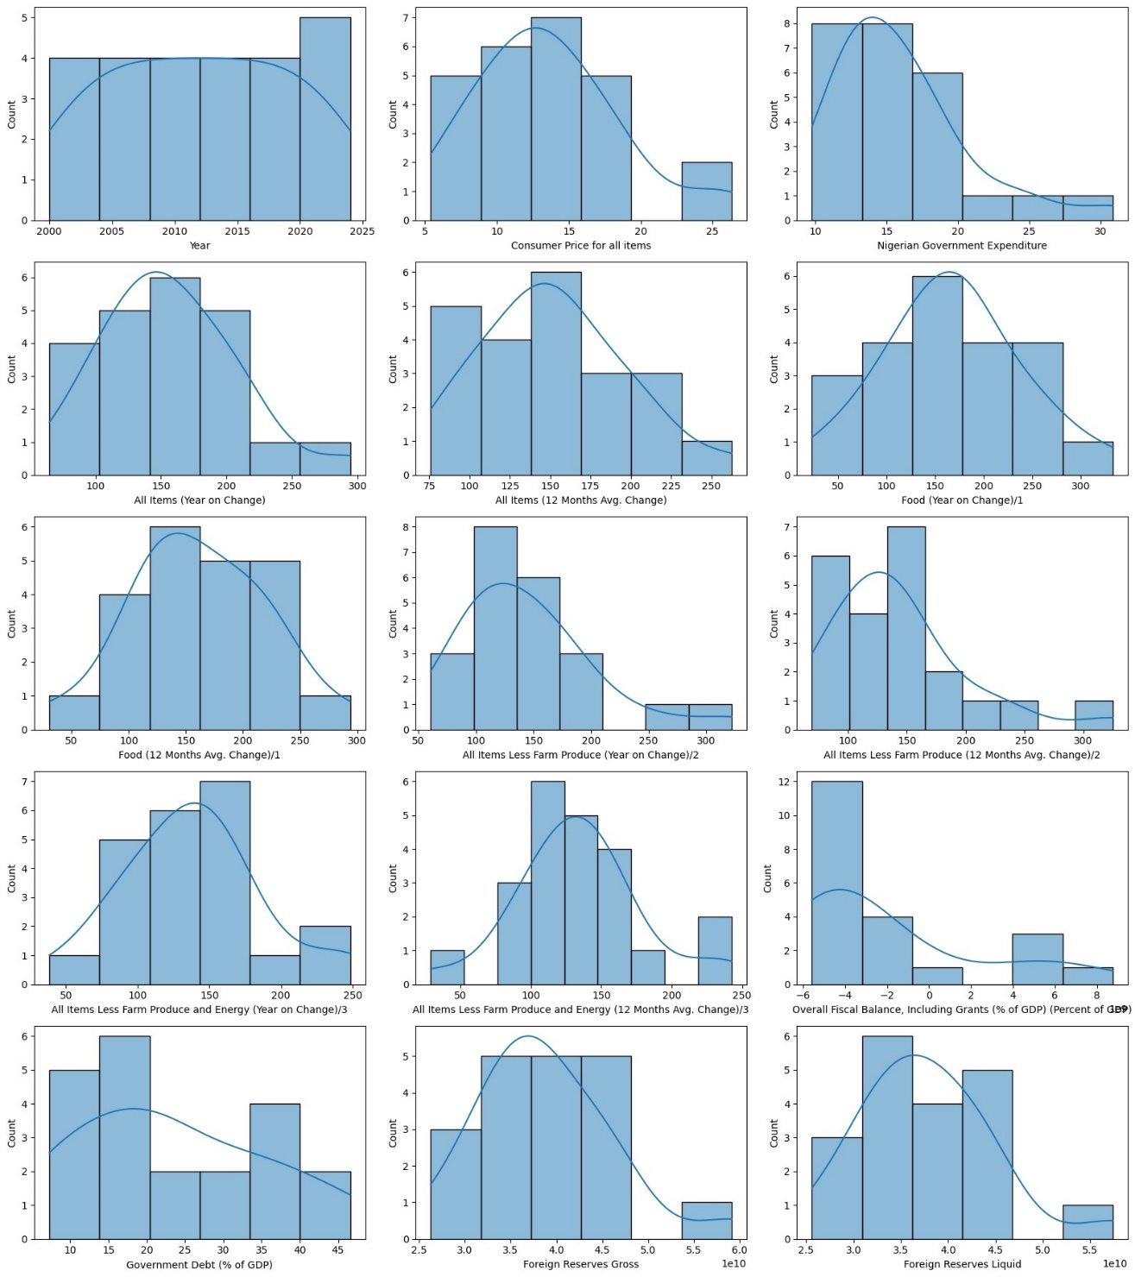**Nigerian Government Expenditure**: This histogram is right-skewed, suggesting that most data points are concentrated on the lower end of expenditure, with fewer instances of higher expenditures.
4. **All Items (Year on Change)**: This histogram shows a roughly normal distribution, indicating that changes in all items year on year are centered around a specific value with a symmetric distribution.
5. **All Items (12 Months Avg. Change)**: Similar to the previous one, this histogram also shows a roughly normal distribution, indicating a centered change in all items over 12 months.
6. **Food (Year on Change)/1**: This histogram is somewhat uniform but with a slight concentration around the middle values, indicating variation in yearly food price changes.
7. **Food (12 Months Avg. Change)/1**: This histogram is similar to the yearly change, with a slight concentration around the middle values, indicating a distribution of average changes in food prices over 12 months.
8. **All Items Less Farm Produce (Year on Change)/2**: This histogram shows a roughly normal distribution, indicating changes in non-farm produce items are centered around a specific value.
9. **All Items Less Farm Produce (12 Months Avg. Change)/2**: This histogram is similar to the previous one, showing a roughly normal distribution for average changes over 12 months.
10. **All Items Less Farm Produce and Energy (Year on Change)/3**: This histogram is roughly normal, indicating yearly changes in items excluding farm produce and energy are centered around a specific value.
11. **All Items Less Farm Produce and Energy (12 Months Avg. Change)/3**: This histogram is similar to the previous one, showing a roughly normal distribution for average changes over 12 months.
12. **Overall Fiscal Balance, Including Grants (% of GDP) (Percent of GDP)**: This histogram is right-skewed, indicating that the majority of fiscal balances are on the lower end, with fewer instances of higher balances.
13. **Government Debt (% of GDP)**: This histogram is somewhat uniformly distributed, indicating a spread of government debt percentages across different ranges.
14. **Foreign Reserves Gross**: This histogram is roughly normal, indicating gross foreign reserves are centered around a specific value.
15. **Foreign Reserves Liquid**: This histogram is similar to the gross reserves, showing a roughly normal distribution, indicating liquid foreign reserves are centered around a specific value.

Overall, the histograms suggest various distributions of the data points across different indicators, with some showing normal distributions and others being skewed or uniformly distributed.

**3-2- Univariate Analysis: Box Plots**

The box plots provide a concise summary of the data's central tendency, variability, and the presence of outliers for each feature. As shown, most features display relatively symmetric interquartile ranges (IQRs), with median values well-centered within the boxes, suggesting a balanced distribution. However, several features exhibit significant outliers, which are points lying outside the whiskers, indicating potential anomalies or extreme values. The spread of data, as indicated by the length of the whiskers, varies across features, reflecting differences in data variability. These observations are consistent with the insights gained from the histograms, reinforcing the patterns of distribution, central tendency, and outliers in the dataset.

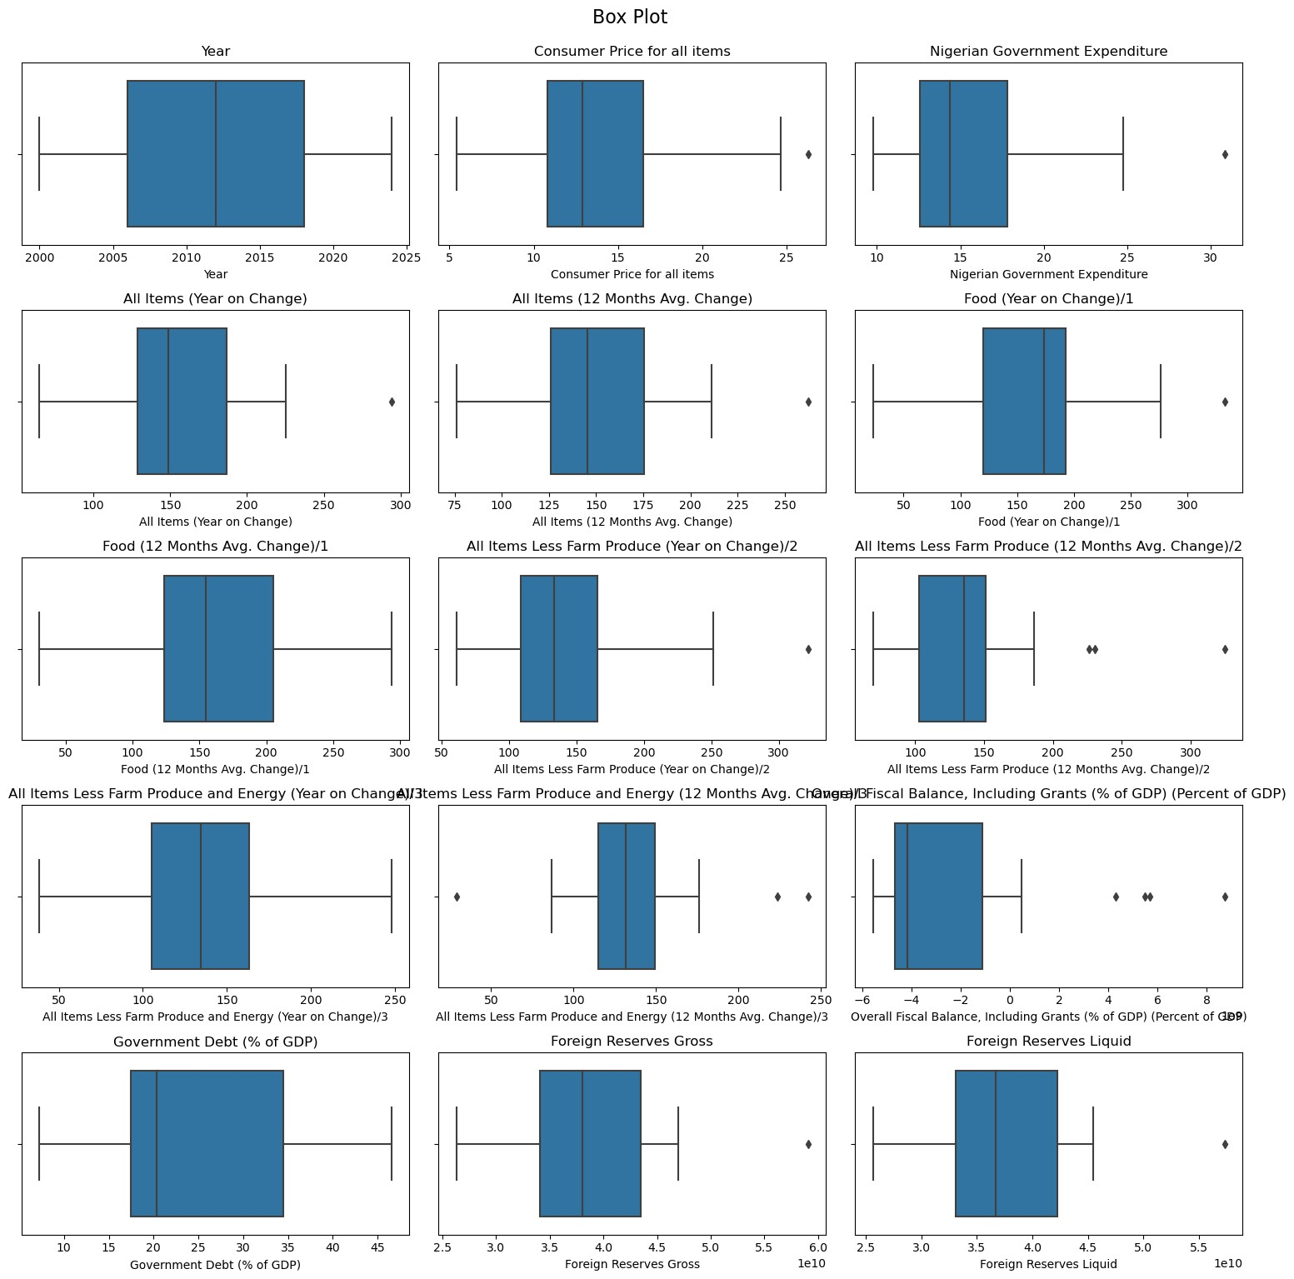

**3-3- Univariate Analysis: Violin Plots**

The violin plots provide a comprehensive view of the data distributions, illustrating the density and spread of each feature. As presented, most features display symmetric distributions with a concentration around their medians, reflecting balanced datasets. A few features, such as Nigerian Government Expenditure and Overall Fiscal Balance, show skewness, indicating an uneven spread of values. These plots confirm the presence of outliers in some features, which align with the observations from the histograms and box plots. Overall, the violin plots offer a nuanced depiction of the data, highlighting the central tendency and variability across different features.  
  
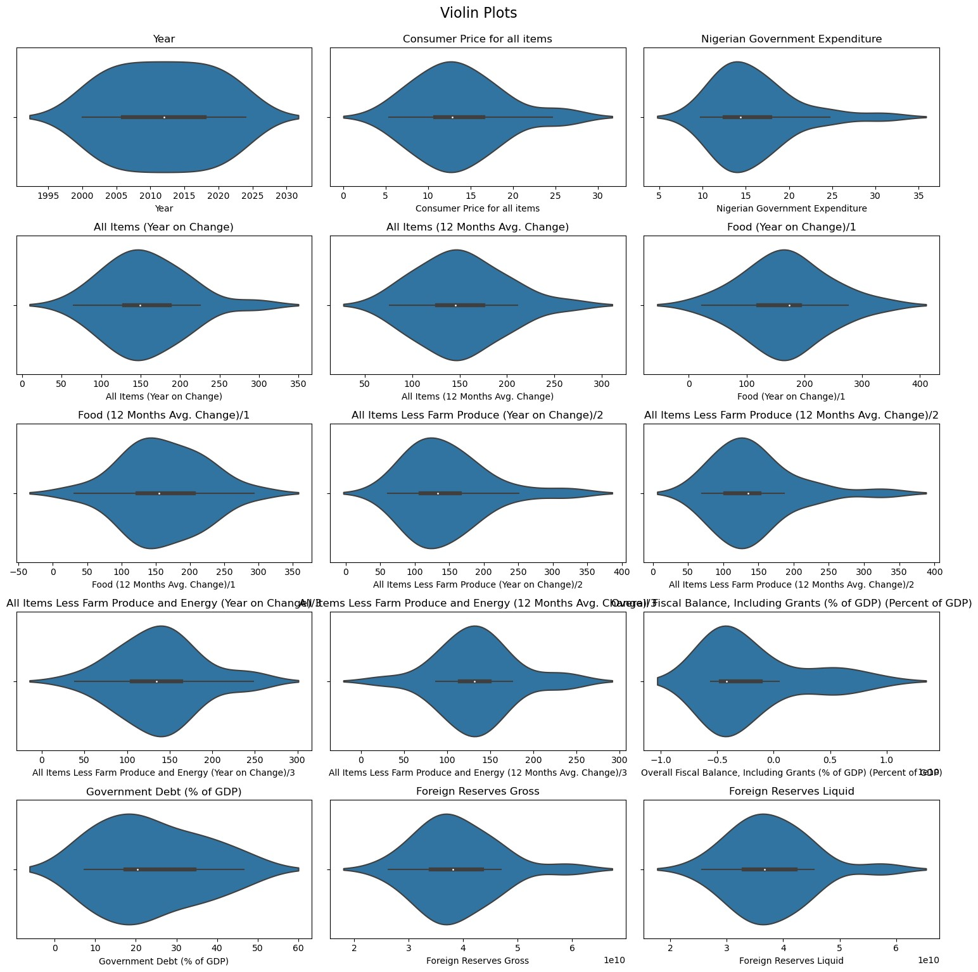  
**4- Correlation Analysis:**

The correlation analysis of the given features was performed and the correlation heat map is shown below.

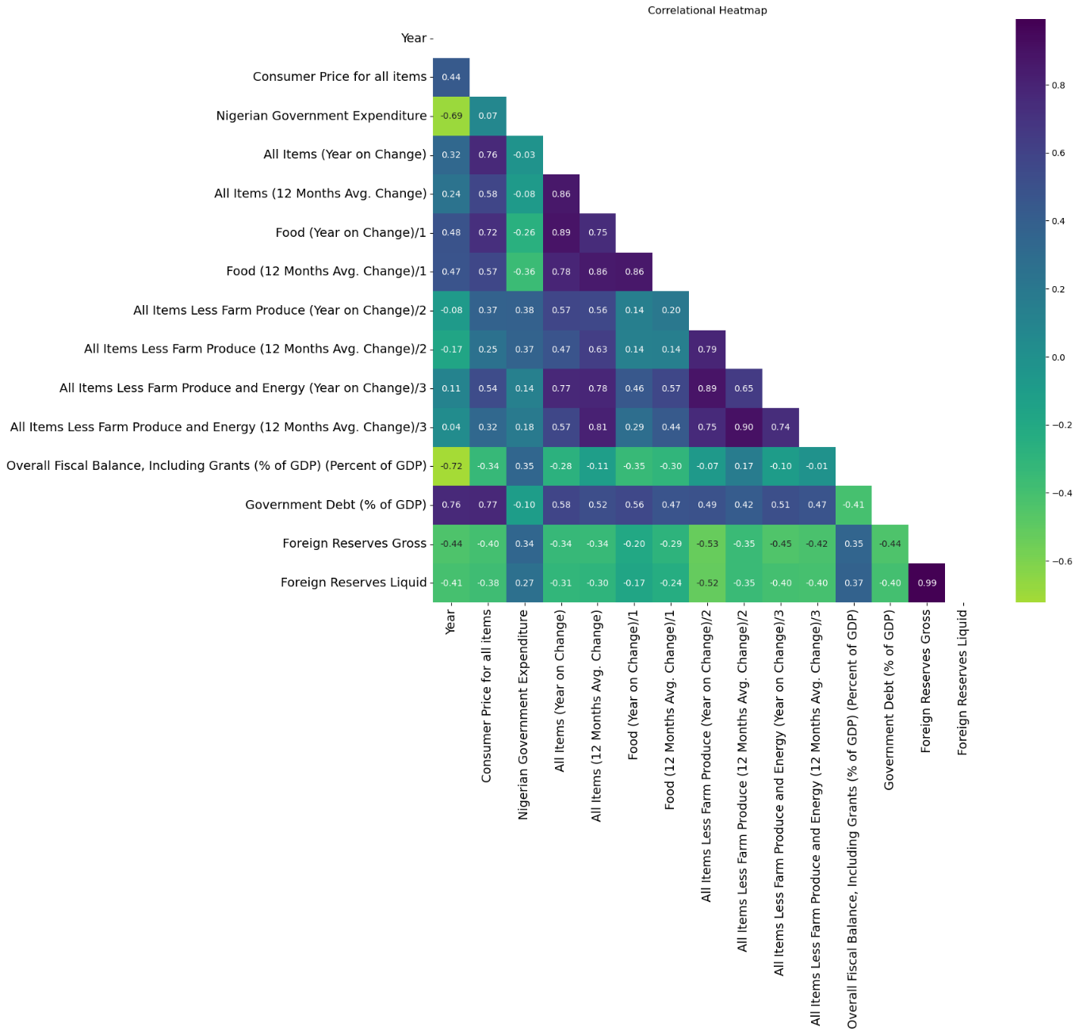

**4-1- Strongest Positive Correlated Features (Correlation > 0.80)**

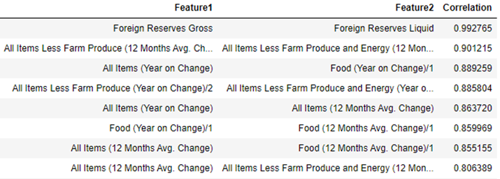Additionally, the analysis of strongly positively correlated features (correlation > 0.80) reveals key relationships:

* Foreign Reserves Gross *vs.* Foreign Reserves Liquid (**Corr: 0.993**): Highly correlated, indicating synchronized changes.
* All Items Less Farm Produce (12 Months Avg. Change) *vs.* All Items Less Farm Produce and Energy (12 Months Avg. Change) (**Corr: 0.901**): Shows closely aligned average changes.
* All Items (Year on Change) *vs*. Food (Year on Change)/1 (**Corr: 0.889**): Strong correlation, indicating similar yearly price fluctuations.
* All Items Less Farm Produce (Year on Change) *vs.* All Items Less Farm Produce and Energy (Year on Change) (**Corr: 0.886**): Yearly changes closely related, excluding farm produce and energy.
* All Items (Year on Change) *vs*. All Items (12 Months Avg. Change) (**Corr: 0.864**): Consistent price fluctuations over different time scales.
* Food (Year on Change)/1 *vs.* Food (12 Months Avg. Change)/1 (**Corr: 0.860**): Strong correlation between yearly changes and twelve-month averages in food prices.
* All Items (12 Months Avg. Change) *vs.* Food (12 Months Avg. Change)/1 (**Corr: 0.855**): Indicates a strong relationship in average price changes over twelve months.
* All Items (12 Months Avg. Change) *vs.* All Items Less Farm Produce and Energy (12 Months Avg. Change) (**Corr: 0.806**): Shows closely aligned average changes over twelve months.

**4-2- Strongest Negative Correlated Features (Correlation < -0.5)**

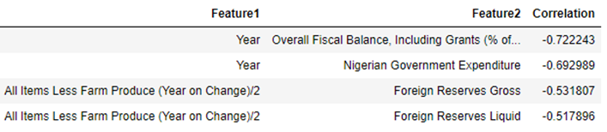As well, the analysis of strongly negatively correlated features (correlation < -0.5) reveals significant relationships within the dataset:

* Year *vs.* Overall Fiscal Balance, Including Grants (% of GDP) (**Corr: -0.722**): As years progress, fiscal balance tends to decrease.
* Year *vs*. Nigerian Government Expenditure (**Corr: -0.693**): Government expenditure tends to decrease over time.
* All Items Less Farm Produce (Year on Change)/2 *vs.* Foreign Reserves Gross (**Corr: -0.532**): Decreases in yearly prices (excluding farm produce) correlate with increases in foreign reserves gross.
* All Items Less Farm Produce (Year on Change)/2 *vs.* Foreign Reserves Liquid (**Corr: -0.518**): Decreases in yearly prices (excluding farm produce) correlate with increases in foreign reserves liquid.

In the following, more insight has been provided into "Government Debt (% of GDP)", " Consumer Price for all items ", and “Nigerian Government Expenditure" features.

1. **Insight into "Government Debt (% of GDP)"**

The "Government Debt (% of GDP)" feature has 21 observations with an average value of 23.59 and a high variability. The data ranges from 7.28 to 46.59, with the median at 20.33. The interquartile range (IQR) extends from 17.43 to 34.49, indicating a significant spread in the middle 50% of values.

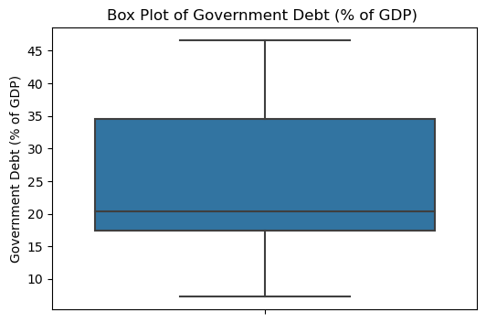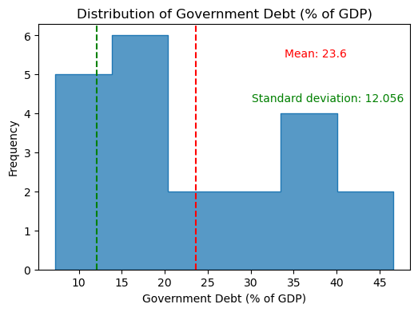

**5-1- Government Debt (% of GDP) and Correlated Features**

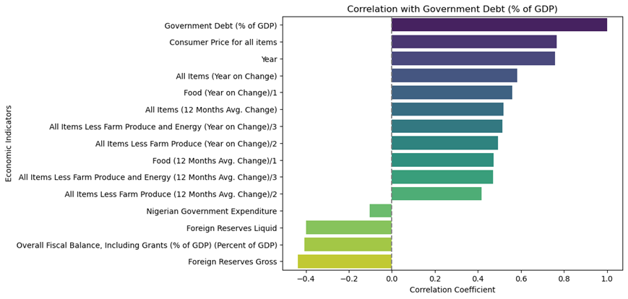Additionally, findings indicate that the "Government Debt (% of GDP)" shows strong positive correlations with consumer prices (0.766) and year (0.759). It has moderate positive correlations with various inflation measures, such as year-on-year changes in all items (0.582) and food prices (0.559). Negative correlations are observed with foreign reserves (gross: -0.437, liquid: -0.400) and overall fiscal balance (-0.407).

**5-2- Government Debt (% of GDP) and Changes over Years**

Considering the changes in Government Debt (% of GDP) over the years represent:

* In **2004**, government debt as a percentage of GDP began at **35.49%** and decreased to **18.94%** by **2005**.
* From **2006** to **2008**, there was a significant decrease in government debt relative to GDP, reaching a low of **7.28%** in **2008.**
* Debt increased slightly in **2009 (8.62%)** and showed a noticeable increase in **2010 (9.39%)** and **2011 (17.43%)** following global economic challenges.
* From **2012** onwards, government debt as a percentage of GDP generally increased steadily, with fluctuations. By **2024**, it reached approximately **46.59%**.

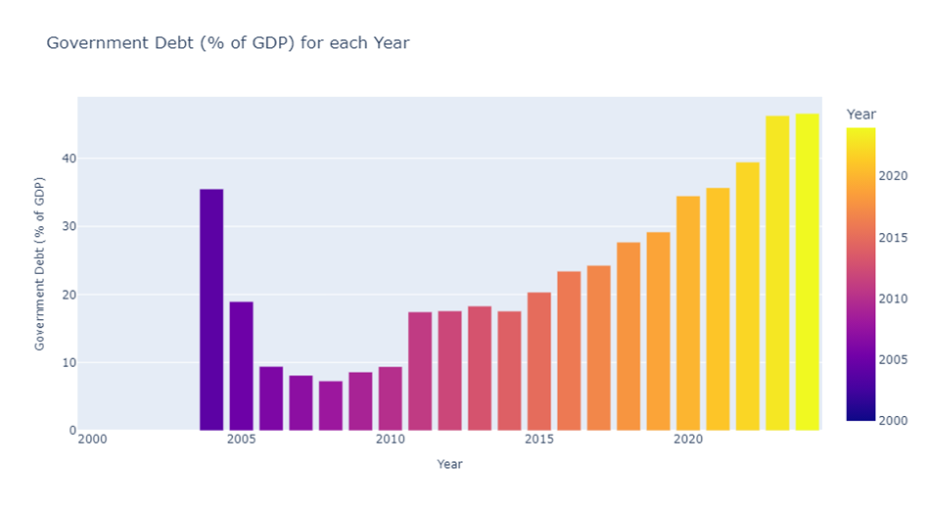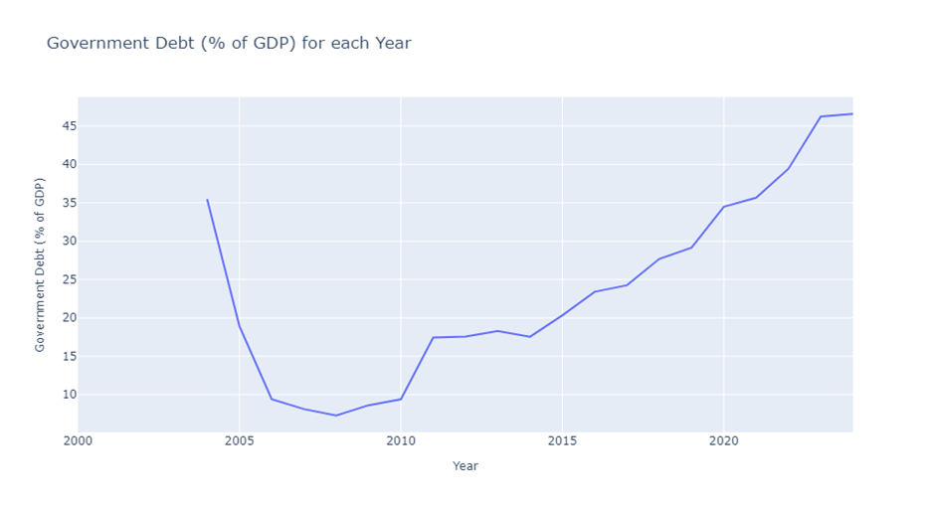

Also, the analysis of significant changes in "Government Debt (% of GDP)" reveals two notable years:

* **2006**: The government debt decreased significantly by **50.35%** compared to the previous year.
* 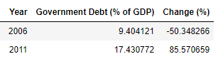**2011**: There was a substantial increase in government debt by **85.57%** from the previous year

1. **Insight into "Consumer Price for all items"**

The "Consumer Price for all items" feature has an average of 13.65 with moderate variability. The data ranges from 5.40 to 26.31, with the median at 12.88. Most values lie between 10.83 and 16.50, though there are some high-value outliers. Overall, the distribution is fairly balanced.

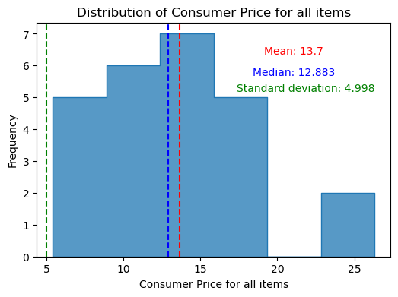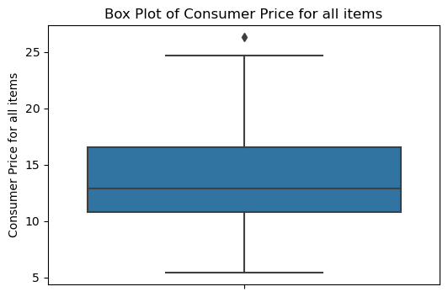

**6-1- "Consumer Price for all items" and Correlated Features**

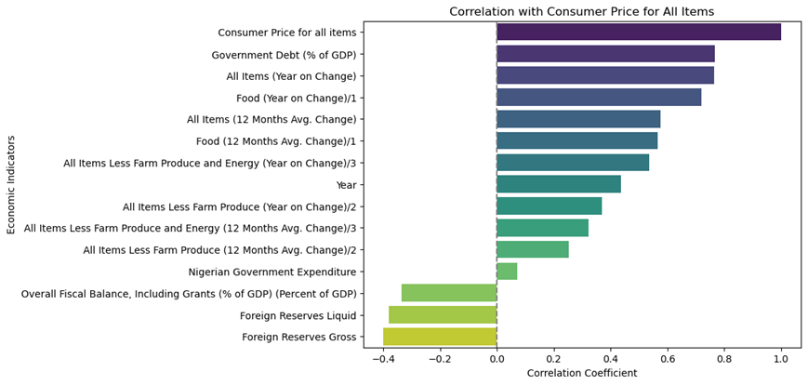The "Consumer Price for all items" shows strong positive correlations with government debt (0.766), year-on-year changes in all items (0.763), and food prices (0.721). There are moderate correlations with 12-month average changes in all items (0.576) and food prices (0.566). Weak negative correlations are observed with overall fiscal balance (-0.336) and foreign reserves, both liquid (-0.380) and gross (-0.399).

**6-2- "Consumer Price for all items" and Changes over Years**

Insight into the changes in "Consumer Price for all items" over the years also shows that:

* The data shows a fluctuating trend in the Consumer Price Index for all items from **2000** to **2024**.
* The early **2000s** experienced high inflation, peaking in **2001**.
* Mid-decade, there was a notable decrease, particularly in **2007**.
* The CPI remained relatively stable in the early **2010s** but began to rise again towards the end of the decade.
* In recent years, there has been an upward trend, with the CPI reaching its highest levels in **2023** and **2024**.

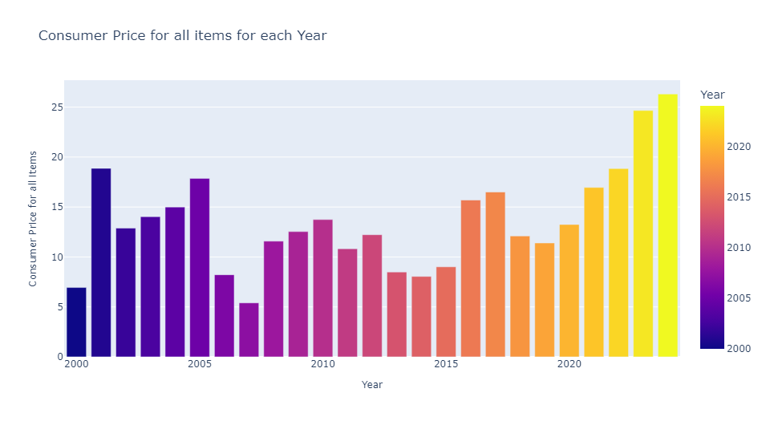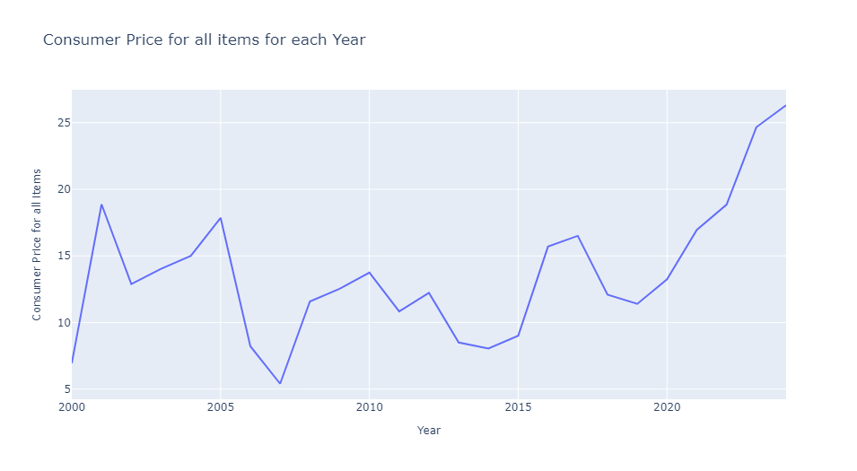

Furthermore, the analysis of "Consumer Price for all items" revealed significant changes in four years.

* In **2001**, the CPI surged by **171.99%,** followed by a **53.98%** decrease in **2006**.
* It spiked again by **114.41**% in **2008** and increased by **74.19%** in **2016**.

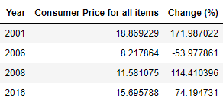These changes highlight periods of sharp inflation spikes and reductions, indicating considerable volatility in consumer prices over the years.

1. **Insight into "Nigerian Government Expenditure"**

The "Nigerian Government Expenditure" feature includes 25 observations. The average expenditure is approximately 15.96, with a moderate standard deviation, indicating some variability around the mean. The expenditures range from 9.76 to 30.86, with the median (50th percentile) at 14.38. The interquartile range (IQR), spanning from 12.56 to 17.81, encompasses the middle 50% of values.

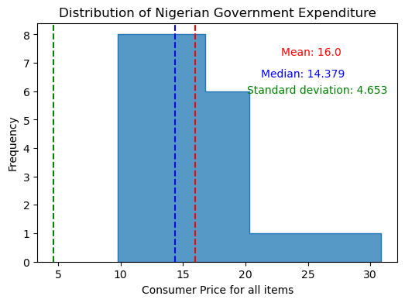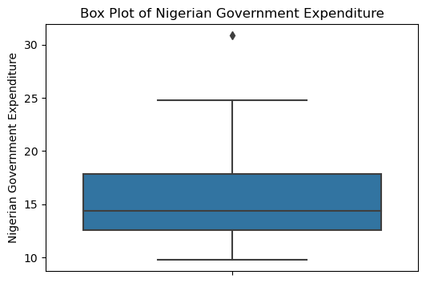

**7-1- "** **Nigerian Government Expenditure " and Correlated Features**

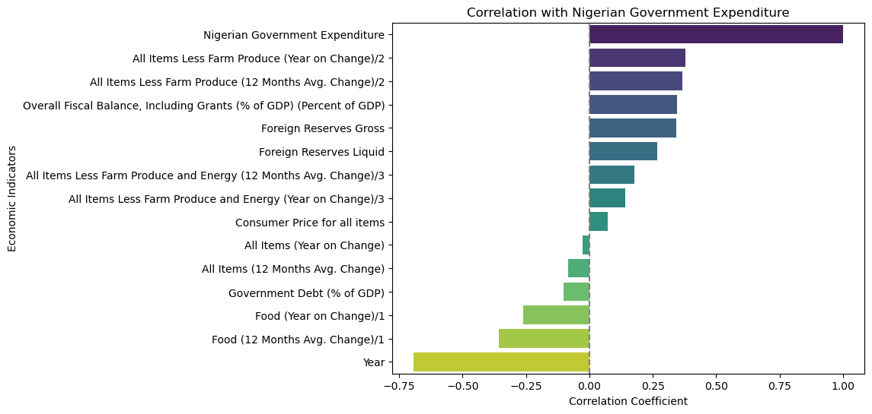The "Nigerian Government Expenditure" shows the highest positive correlation with "All Items Less Farm Produce (Year on Change)/2" (0.38) and the least correlation with "Year" (-0.69). It has moderate positive correlations with "All Items Less Farm Produce (12 Months Avg. Change)/2" (0.37) and "Overall Fiscal Balance, Including Grants (% of GDP)" (0.35). It is slightly negatively correlated with "Food (12 Months Avg. Change)/1" (-0.36) and "Government Debt (% of GDP)" (-0.10).

**7-2- "** **Nigerian Government Expenditure " and Changes over Years**

The findings indicate changes in the Nigerian Government Expenditure over the years, specifically:

* Government expenditure generally shows a declining trend from 2000 to around 2006, followed by fluctuations with no clear upward or downward trend until 2015.
* Expenditure remained relatively stable from 2016 to 2021, with slight fluctuations.
* In 2022 and 2023, there was a slight increase in expenditure, possibly indicating economic adjustments.
* A notable increase in 2024 suggests a potential shift in fiscal policy or economic priorities.

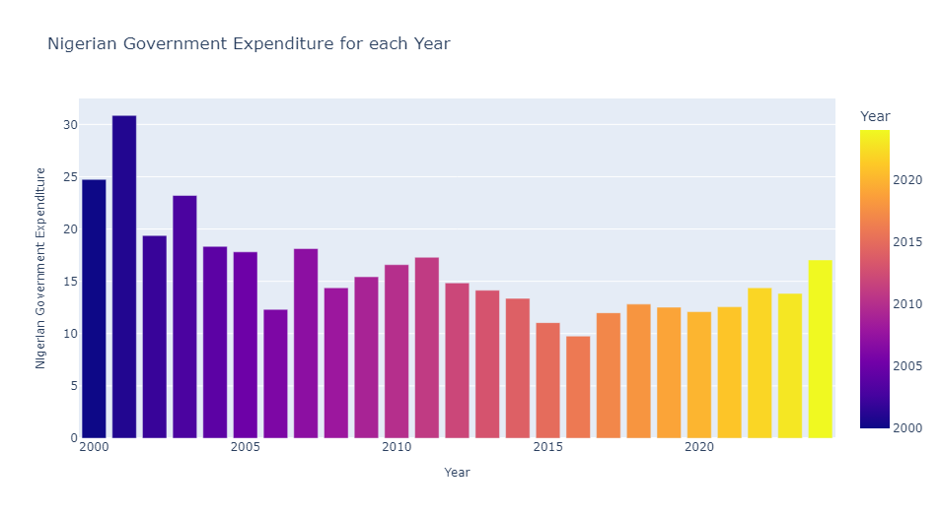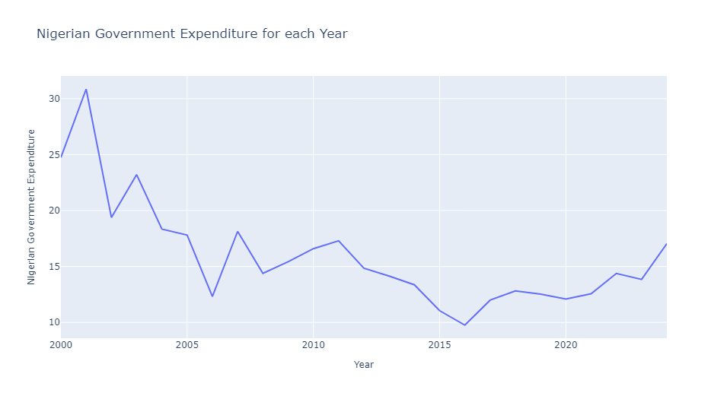

The significant changes in Nigerian Government Expenditure over the years also indicated that:

* In **2002**, there was a significant decrease of approximately **-37.19%** in government expenditure compared to **2001**.
* In **2006**, government expenditure decreased significantly by about **-30.85%** compared to **2005**.
* 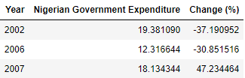In **2007**, there was a notable increase of about **47.23%** in government expenditure compared to **2006**.